### Assignment:

### Laravel New Project Setup and Views

Creating a Laravel application involves several steps, including installation, setting up routes, and creating views. Below is a step-by-step guide to help you get started with a basic Laravel application. Since I can't provide screenshots, I'll describe each step clearly.

**Step 1: Install Laravel**

1. **Set Up Environment**:
   * Ensure you have PHP (>= 7.4), Composer, and a local server (like XAMPP) installed.
2. **Open Terminal**:
   * Navigate to the directory where you want to create your Laravel project.
3. **Create a New Laravel Project**:

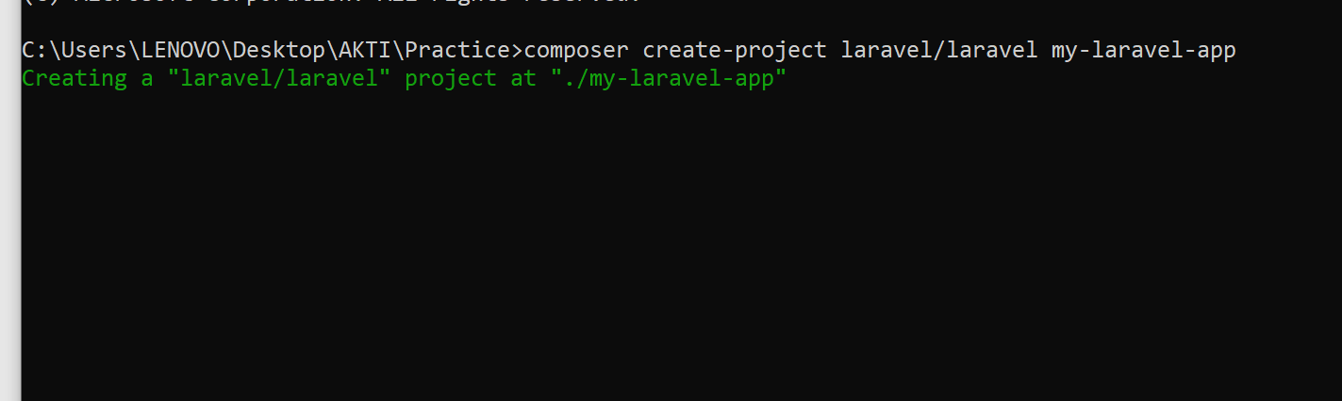

**Step 2: Serve the Application**

1. **Navigate to Your Project Directory**:

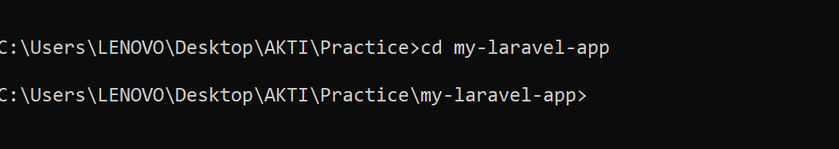

1. **Run the XAMPP Server**:

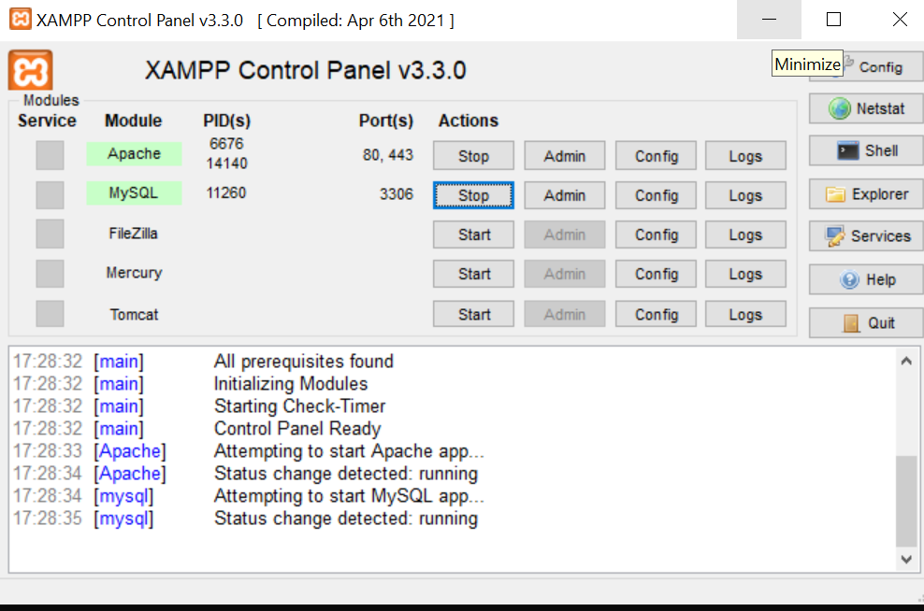

Type the following command to run the server

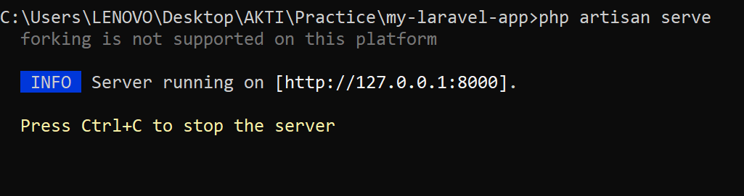

* + This will start a local server at http://localhost:8000.

**Step 3: Set Up Routes**

1. **Open Routes File**:
   * Go to routes/web.php.

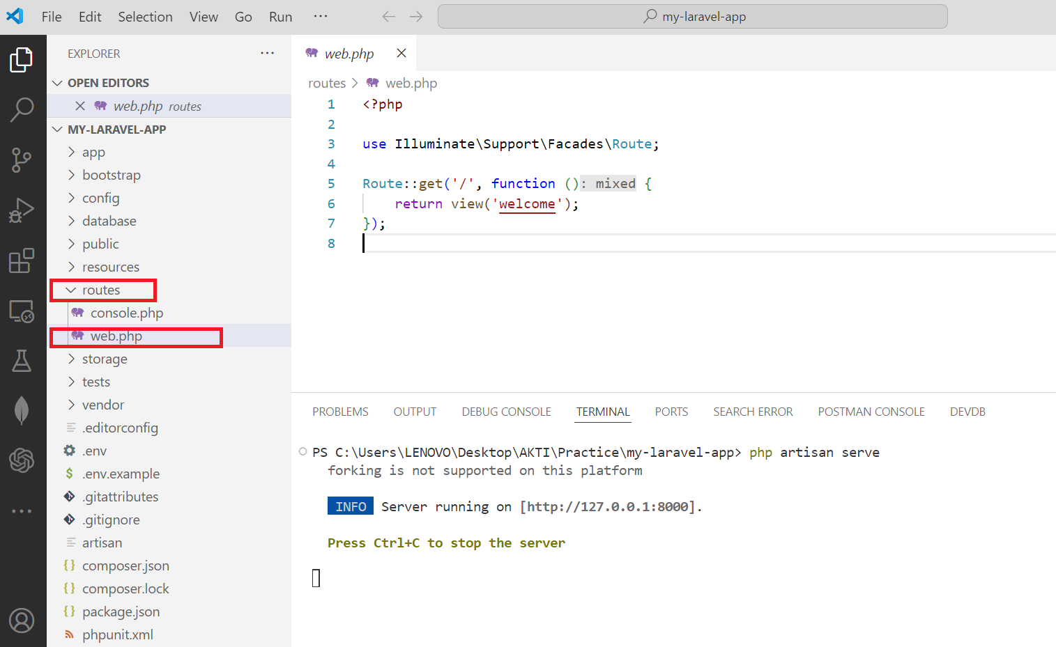

1. **Add Routes**:

Add the following code to the routes/web.php file

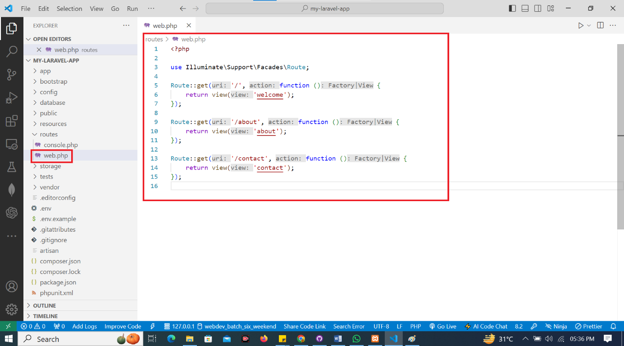

**Step 4: Create Views**

1. **Create a Views Directory**:
   * Go to resources/views.
2. **Create Blade Files**:
   * Create three files: welcome.blade.php, about.blade.php, and contact.blade.php.
3. **Add Content to Each File**:
   * **welcome.blade.php**:

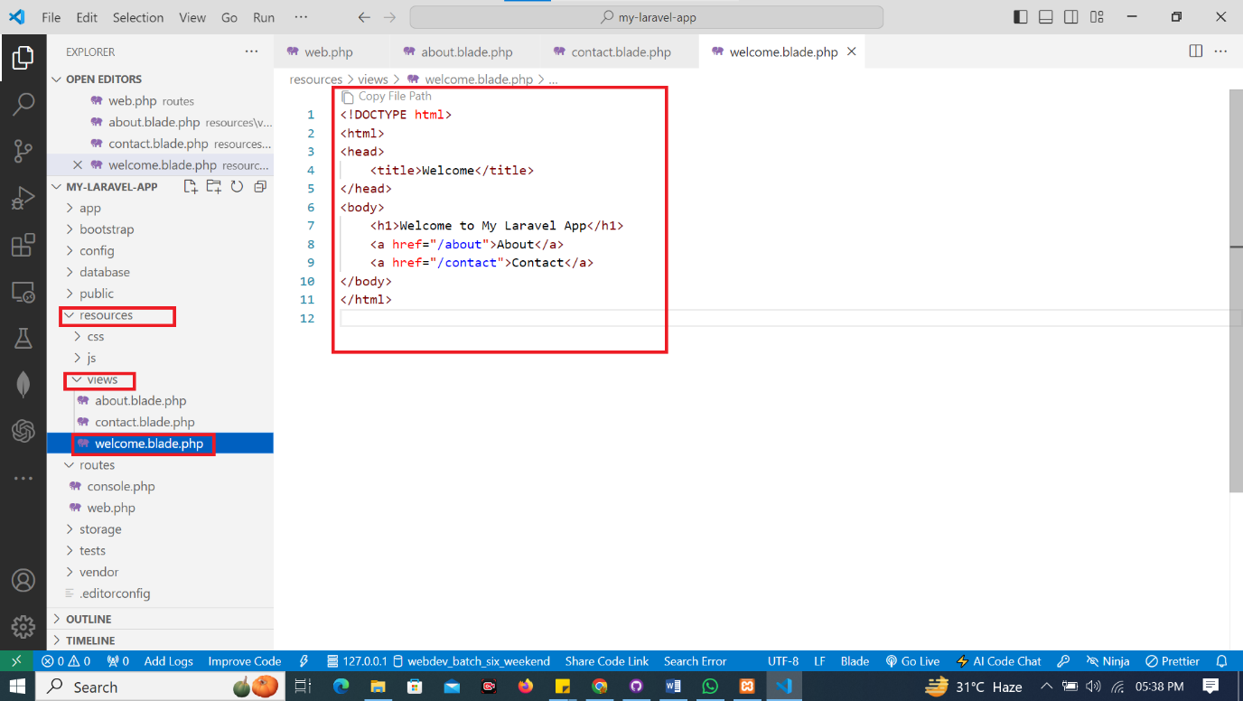

* + **about.blade.php**:

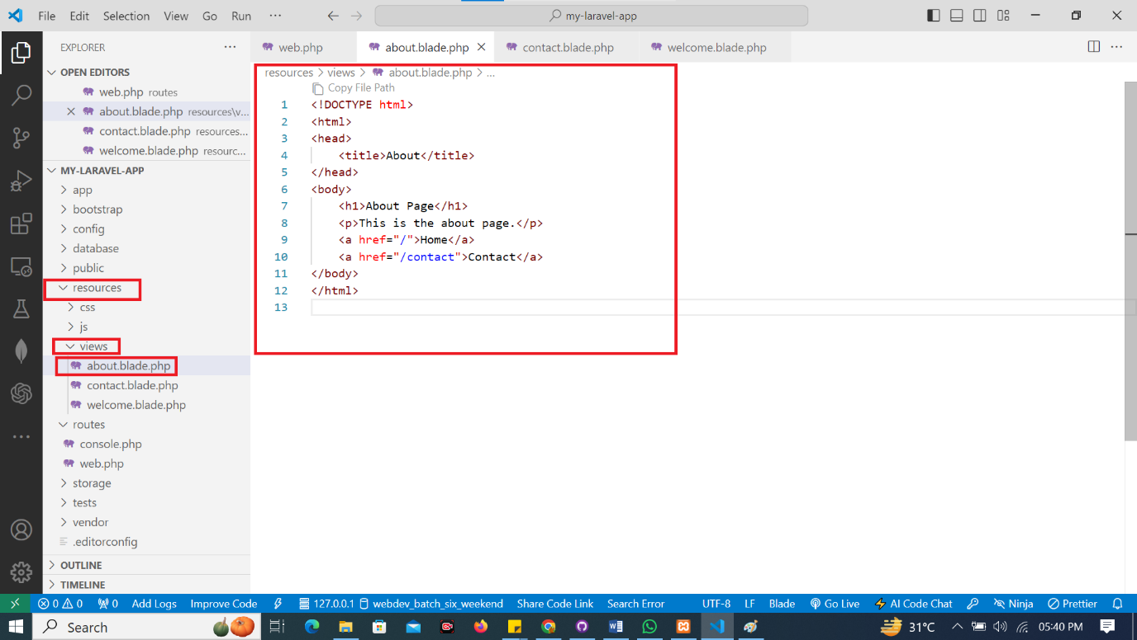

* + **contact.blade.php**:

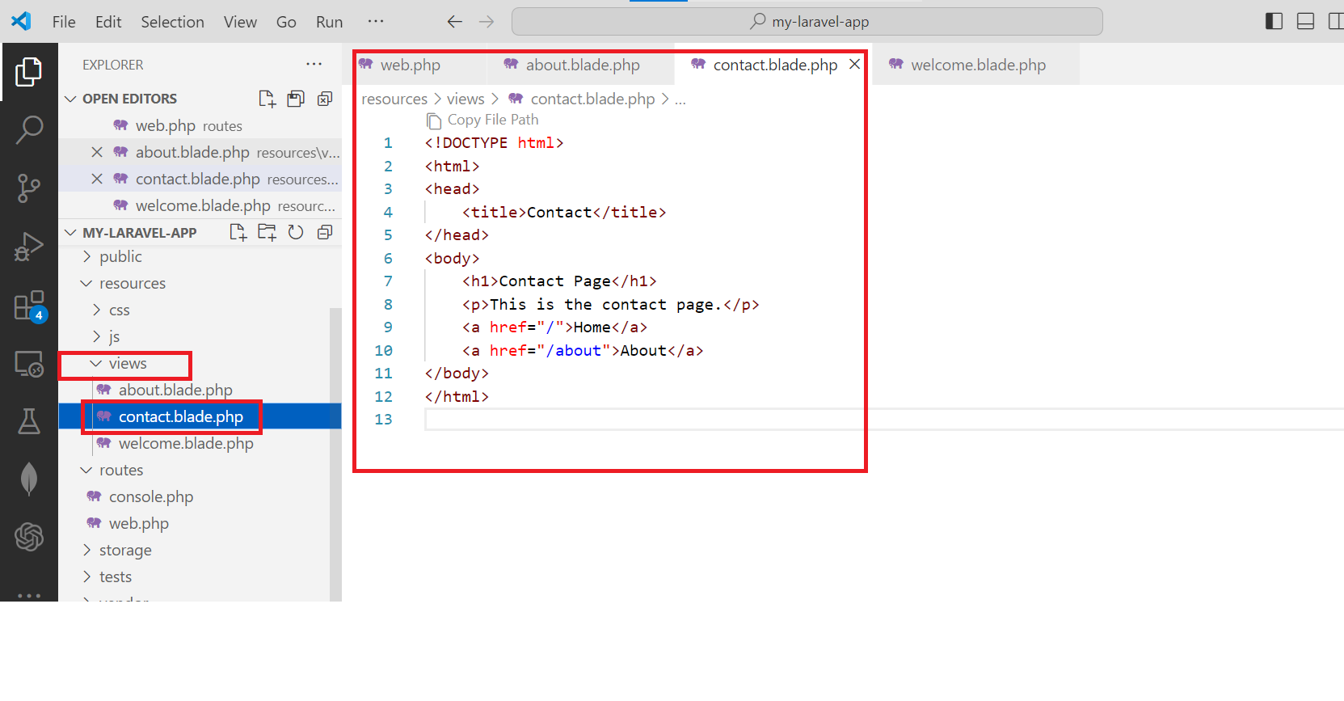

**Step 5: Test Your Application**

1. **Open Your Browser**:
   * Go to <http://localhost:8000>.

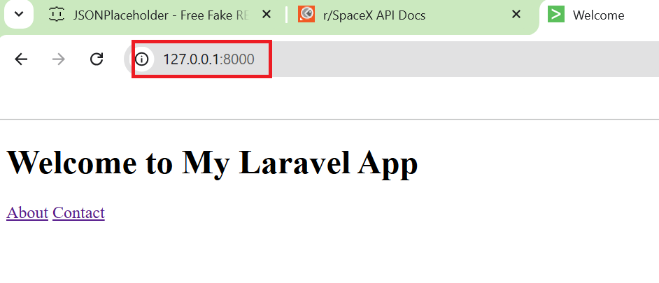

1. **Navigate Through the Pages**:
   * Click on the links to navigate to the About and Contact pages.

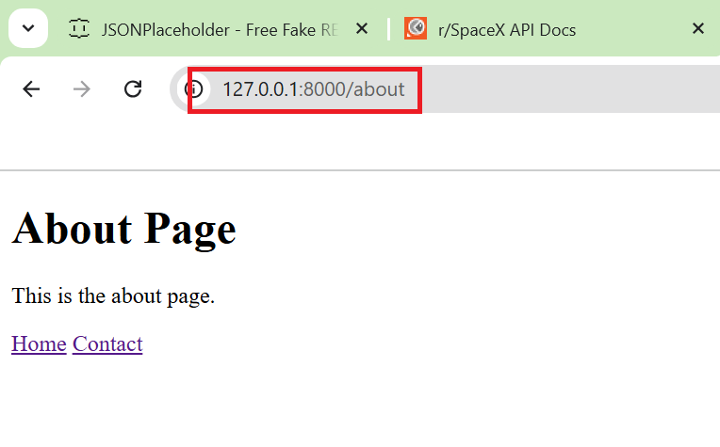

**Step 6: Customize Further (Optional)**

* You can add CSS for styling, JavaScript for functionality, and database integration for more complex applications.

**Conclusion**

You now have a basic Laravel application with different routes and views. You can expand this structure by adding controllers, models, and database migrations as you progress. For more advanced features, consider exploring Laravel's documentation.